

All Eyes on the Evidence: Classifying Expert and Novice Crime Scene Investigators on the basis of Eye Movement Patterns

Master Thesis - Data Science: Business and Governance  
The School of Humanities and digital Sciences

**Author:** Décio J. Da Silveira Quiosa  
**Studentnumber:** 2017433

**ANR:** u283203  
**Supervisor:** Frouke Hermens

**Second reader:**

**Theme:** Eye tracking in Crime scene investigation

December 2018

Tilburg University, Tilburg

# Preface

# Abstract

# 1 Introduction

## Context

Observation of the scenery around us does not happen in one glance, rather we observe our surroundings one small area at the time fixating our fovea onto different objects so we can allow our visual oculomotor system absorb the environment in a fine grained manner.

## Research questions

This research project aims to determine whether eye movement patterns can be used to distinguish between expert crime scene investigators and novices in a classification task. In addition, this project aims to examine the role of context (live crime scene investigation or based on images of the crime scene).

* ~~Which eye movement measurements contain the most information on expertise?~~
* ~~On the basis of which eye movements can we classify expertise?~~
* ~~Are these eye measurements consistent throughout different content and experimental setups?~~
* ~~Evaluate if simulation is a good proxy for live examination~~

## Findings

[**http://citeseerx.ist.psu.edu/viewdoc/download?doi=10.1.1.67.6184&rep=rep1&type=pdf**](http://citeseerx.ist.psu.edu/viewdoc/download?doi=10.1.1.67.6184&rep=rep1&type=pdf)

# 2 Related work

Gaze behavior is an important component of attention and perception and has a substantial impact on information processing of an individual (Rizolatti, Riggio, Dascola & Umilta, 1987). The mechanisms that underlie our gaze behavior are generally classified into two categories. Whilst top-down mechanisms direct our visual attention to the task at hand, bottom up mechanisms ensure that our visual attention is directed to particular points of interest (e.g. noteworthy visual attributes of photographs) (Kollmorgen et al., 2010).The mechanism driven by stimuli is also known as visual saliency (Bruce & Tsotsos, 2009). Over the past decades, most research into gaze behavior seem to agree eye movements contain information in affluence about cognitive processes (Rayner, 1998). Hence, eye gaze behavior may be regarded as a valuable tool to understand expertise.

***Theories of visual behavior and eye tracking***

Eye-tracking allows for capturing where a person is looking at any given time. Various eye tracking studies have examined the differences in eye movement patterns between experts and novices in professional domains ranging from sports to medicine (Gegenfurtner, Lehtinen & Säljö, 2011). Examples of non-trivial findings have shown that elite golf players fixate their visual attention for a prolonged amount of time on the ball until they hit target, which is also known as the “Quiet Eye” concept (Vickers, 1992) another example in the surgical domain revealed that highly skilled surgeons as opposed to novices spend less time tracking the position of their tools during surgery (Vine et al., 2013).

Several theories that explain expertise through visual behavior have been outlined in a meta-analysis by Gegenfurtner et al., (2011): The information reduction theory (Haider & Frensch, 1999), the long-term working memory theory and the holistic model of image perception (Kundel et al. 2007). The holistic model of image perception proposes that experts are capable of widening their visual span by processing global information (Kundel et al. 2007). The long-term working memory suggests that experts, in contrast to, novices are capable of relying on their long term working memory as an extension of their working memory enabling faster processing of visual information due to retrieval structures (Ericsson & Kintsch, 1995). Finally, the most prevalent theory that offers an explanation for differences in gaze behavior between experts and novices is the information reduction theory (Haider & Frensch, 1999). This theory suggests that experts tend to reduce irrelevant information that needs to be processed by solely focusing on task-related visual stimuli and ignore unnecessary cues. Haider and Frensch (1999) showed in their work that expert air traffic controllers reduce the amount of visual information to be processed by solely focusing on task-related visual cues.

Often the aim of these studies is to understand the differences between experts and novices using their eye movement patterns. An illustration of why comparisons between experts and novices might be relevant can be found in laparoscopic surgery (surgery through small incisions). What makes laparoscopic surgery particularly interesting are the substantive results that lead to the contradictory situation of having favorable economic and societal outcomes related to fast recoveries for patients (due to small incisions), that comes at the cost of increased complexity of operations and higher skill demands for surgeons (Hermens, Flin and Ahmed, 2013; Reiley, Lin, Yuh and Hager, 2011).

These demands in combinations with technological improvements of eye movement trackers are a catalyst for increased interest in improvement of training for novice surgeons based on eye movements (Hermens et al., 2013). Substantial evidence of improved training as a result of mimicking visual behavior can be found in the work of Vine et al. (2013) who has shown that novices who received gaze training in order to adopt the same eye movements as experts obtained higher skill levels and moreover skills were retained for a longer period of time.

**Visual search within the CSI domain**

Reasons to believe that eye movement differences may extend to and have an important role within the CSI domain as a premise of the information reduction theory are the intertwined dynamics of selectively applying attention to objects, switching this attention between objects and fixating on certain areas of interest. These dynamics are inherent to examining a crime scene and are known as covert orientation (Hunt and Kingstone, 2003). The presence of these dynamics are corroborated by several studies. Baber and Butler (2012) showed that CSI experts tend to focus selectively on objects with “evidential value” and Watalingam, Richetelli, Pelz and Speir (2017) theorized that experts have a tendency towards hypothesizing in the process of interpreting evidence.

Given that CSI has a pivotal role to forensic analysis in the sense that it determines what elements of the crime scene is selected as evidence. Wrongful selection of evidence can lead to an increased workloads in laboratories, whereas a more effective CSI can speed up analysis (Watalingam et al., 2017).

Th

In addition, objective assessment of skill can lead to improved training as in Vine et al. (2013).

Whilst the aforementioned theories of visual behavior are corroborated in various domains such as chess (Sheridan & Reingold, 2014) and slalom skiing (Decroix et al., 2017), the applicability of the theories in each of these examples are dependent on the nature of the task in relation to domain specific characteristics (Prytz, Norén & Jonson, 2018).

Gegenfurtner et al. (2011) provides a taxonomy of task complexity drawn from the work of Wood (1986) and Campbell (1986) proposing that the complexity of a task can be ranked: only *viewing* is the simplest, followed by a moderately difficult *detection* task, a moderately difficult *decision* task and the hardest task a *problem solving* task. This suggests that the difference in expertise as measured by eye movements in the various domains may vary as a function of task complexity (e.g. eye-hand coordination in surgery, visual search).

An example can be found in the work of Prytz et al. (2018). They examined the differences between emergency professionals and novices in conducting a visual search task in order to identify an accident scene. They proposed that in the visual dynamics of selectively searching through task relevant areas are the most strongly linked to the information-reduction theory (Prytz et al., 2018).

However, investigation expertise within the CSI domain on the basis of eye tracking has been researched to a lesser extent in comparison to other domains. In Gegenfurtner’ et al. (2011) review of 71 studies, none was focused on the CSI domain. Previous research within the expert and novice paradigm with regards to visual behavior in a related field, forensic sciences, has studied expertise with regards to signature analysis (Dyer, Found & Rogers, 2006; Merlino, 2014) and fingerprint analysis (Busey et al., 2011).

More recently, Watalingam et al. (2017) examined whether eye movements could be used to distinguish expertise on the basis of sequences of eye fixation and found meaningful differences for sequences of eye fixations between expert and novice and the amount of time. In line with the information reduction hypothesis experts exhibit effective behavior in the sense that they spent a reported 88% of their time searching for evidence, whereas novices spent 86% of their time searching for evidence which is a small difference (Watalingam et al. 2017).

Around the same time, Ozger (2016), in the context of his PhD project, used eye tracking to understand expertise in the CSI field through eye movement patterns. In three experiments expert and novices were compared on search tasks differing in context (live examination versus static examination of photos). The focus of these experiments was to gain a better understanding of perceptual and cognitive expertise of crime scene investigators (See methods section for a more in depth explanation).

Additionally, a better understanding of expertise can lead to a more objective assessment of skill due to the ecological validity of eye measurements. Assessment based on results can have unfavorable and biased outcomes. It is reasonable that experienced CSI will take on the more challenging cases in the same way that more experienced surgeons are more likely the ones taking up more complex cases (Hermens, 2013).

**Gaze behavior and measures derived from Eye-tracking**

Gaze behavior is a complex source of information and analysis relies on a wide range of measures (Coutrot et al., 2018). The main measures found in literature belong to the oculomotor approach and include metrics such as fixations and saccades (Gegenfurtner et al., 2011; Ozger, 2016). An eye fixation is characterized by the maintenance of the visual focus on a single location and a saccade are small eye movements between fixations when a person relocates visual focus (Gegenfurtner et al., 2011). It is assumed that the lion’s share of visual information extraction takes place through covert attention during fixation (Ozger, 2016; Hunt & Kingstone, 2003).

One of the main favorable properties of oculomotor metrics according to Coutrot (2018) is the interpretability and the possibility to generalize these measures, whereas scan paths or graphs of eye movements are stimuli dependent. This allows for a data-driven approach, meaning that analysis can be done solely on eye metrics without considering the different points being looked at (Richstone et al 2010; Hermens, 2013). Table 1 shows an overview of the eye movement metrics related to the information reduction theory drawn from the overview found in the review of Gegenfurtner et al. (2011). These eye movement parameters are further described in the methods section.

*Table 1*

*Operationalization of theories to eye movement measures*

*Adopted from Gegenfurtner et al. (2011)*

|  |  |  |  |
| --- | --- | --- | --- |
| **Explaining theory** | **Premise** | **Related eye movement metric** | **Definition** |
| Information reduction | Efficient allocation of attention by neglecting redundant visual information | Number of fixations  (relevant) | Number of fixations on areas that are relevant for the task. |
| Number of fixations  (irrelevant) | Number of fixations on area that are irrelevant for the task. |
| Fixation duration  (on relevant areas) | Time of one fixation on task relevant areas. |
| Fixation duration  (on irrelevant areas) | Time of one fixation on a task relevant area. |

**Current study**

Research on the subject has been mostly restricted to statistical comparisons of eye movement parameters, but ideally, one would like to determine how well skill can be measured using eye movement parameters (e.g., correct classification rates). The only work that uses classification methods in the context of eye movements and expertise appears to be that of Ahmidi et al. (2010; 2012) and Richstone et al. (2010), examining classification of expert and novice surgeons. While Watalingam et al. (2017) distinguished expertise using scan paths. No attempt has been undertaken to evaluate whether eye movement parameters can be used to classify.

Secondly, less attention went out to evaluate whether the assumptions found in the information reduction theory and corroborated in fields with similar dynamics (e.g. in Prytz et al. 2018) extend to the CSI domain.

The present research aims to examine whether eye movements between expert and novice CSIs differ, whether eye movements can be used to classify expert and novice CSIs, and whether such classification depends on the task (real world eye tracking, on-screen crime scene investigation, or a change detection task). Central to this thesis are the premises found in the Information-reduction theory. Based on the information reduction theory (reference) we expect that experts show shorter durations on task irrelevant areas and longer fixations on task relevant areas (evidence and exit & entry points). Another objective of this research is to evaluate whether eye movements of experts and novices contain enough information to distinguish between the two groups by applying machine learning techniques.

The overall goal is to contribute to our understanding of what constitutes an expert in the field of CSI in terms of eye movement parameters, possibly leading to the objective evaluation of skills and improved training of novices by the means of gaze behavior.

**Problem statement and research questions**

This thesis follows an exploratory approach of evaluating expertise effects in the context of CSI through eye movement metrics. The problem statement is formulated as followed:

*Can eye movement parameters be used to distinguish between experts and novices in the CSI domain?*

First of all, we need to evaluate whether the premises of the information reduction theory extends to the CSI domain. These premises withheld that experts have the tendency to focus their attention selectively to task relevant objects and ignore redundant objects. This resonates into visual behavior as a difference between numbers of fixations. In accordance with Gegenfurtner et al. (2011) we hypothesize that experts have more fixations on relevant objects and fewer fixation on redundant objects. This assumption is leads us to the following research question:

RQ 1) *Are there differences in the number of fixations on task relevant and task redundant areas between CSI experts and novices as a consequence of the information reduction hypothesis?*

* Data-Exploration
* Evaluate this question on Eyelink dataset.

The findings in the first research question guide our exploration with machine learning techniques in order to evaluate whether eye movement measures contain enough information to distinguish expertise. Hence, the second research question is as follows:

RQ2) *Do eye movement measures within the CSI domain contain enough information in order to predict Skill (Expert or novice) on the basis of eye movement parameters and across tasks?*

* *-> Random-Forrest for variable importance & feature selection.*
* *-> Classification with*
* *Classification for Change - blindness*

*&*

* *Visual search task*

The research follows an exploratory approach employing machine learning techniques. Therefore it may be relevant to state the last research question.

RQ3) *which patterns prevail in the eye moveme**nt data for experts and novices?*

# Methods

## Origin of datasets

This research utilizes data provided by Ozger (2016) from his PhD thesis project (Lincoln University, UK). The data consist of eye movement recordings from two experiments: (1) on-screen crime scene investigation (photographs) and (2) an on-screen change detection task (comparing crime scenes and other scenes). The first experiment was conducted in a lab using photographs presented on a computer screen. This provided a more stable environment and ensured that participants viewed exactly the same stimuli. 36 participants took part across four groups: nine experts, nine intermediate investigators, nine first years’ forensic students (novices) and nine participants without experience. The participants viewed three different photos on a computer screen and their task was to point out evidence by clicking with a mouse on objects. Afterwards they had to formulate their thought process. Scenes were coded for the various AOIs and eye movements assigned automatically. In subsequent analyses AOIs where grouped into evidence, entry and exit point of a scene.

Lastly, the third experiment examined change blindness in two types of scenes: domain specific (14 images) and a domain unspecific (14 images) across nine experts and eleven novices. Change blindness can be described as a failure to notice an otherwise blatant change in a scene or environment (Mack and Rock, 1998). Within the change blindness experiment the flicker approach (display of short blank screen) was used to switch between the photos. In order to avoid motion cues, a blank screen was shown between the photos, each shown for 500 milliseconds. Participants were instructed to click as fast as possible on the button as soon as they detected a change. Table 2 shows an overview of each experimental set-up.

*Table 2*

*Overview of experiments*

|  |  |  |  |
| --- | --- | --- | --- |
| **Experiment** | **Participants** | **Stimuli** | **Type of data** |
| 1 | 36 across 4 levels | Photographs of crime scenes | Fixation by fixation ROI codes |
| 2 | 9 experts and 11 novices | Crime scene and 14 other change blindness images | Fixation on ROIs for crime scenes, accuracy, fixation duration |

*Stimuli*

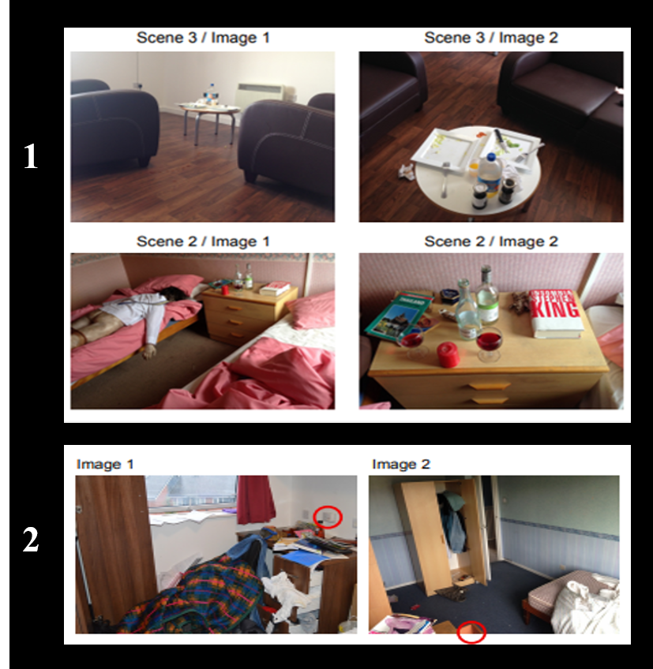

*Figure 1.* Images of visual stimuli in experiment 1 and 2. Figure 1.1 shows the stimuli of experiment 2 in which photographs where shown. From left to right the same photos are shown from different angles.Image 2 shows used Stimuli in the change blindness experiment. Red circles indicate the objects or area that where modified during the change. Adopted from M. Ozger, (2016), *Paying attention to the evidence: a comparison of perception and decision making processes in novice and experienced scene of crime officers using eye tracking in simulated crime scene scenarios*, PhD thesis, University of Lincoln.

*Global versus local approach*

As Coutrot (2017) mentioned, eye movements are dynamic and subject to “idiosyncratic” influences. In addition, we’ve established that saliency strengthens bottom-up effects (Gegenfurtner et al., 2011). Images with salient features are known to attract attention as opposed to images with no salient features. Within crime scene investigation the saliency of a scenery can be objects such as knives or for an example a puddle of blood. Eye coordinates and fixation durations are therefore image dependent.

Based on that knowledge, a twofold approach, globally and locally is designed. Figure 5 illustrates how the analysis was conducted. Models were fit both on aggregated data and the relevant and redundant fixation duration and number of fixations per images (locally).

* *Is it the case that participants only differed per image??*
* *Add explorative nature of this study and on a global level aggregated measures and on a local level per fixation*

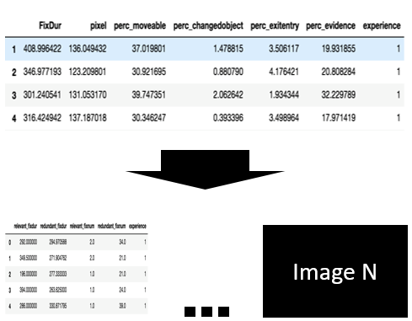

*Figure 5.* Global versus Local. Both the crime scene inspection dataset (CSI-data) and the change blindness dataset were evaluated on a global (aggregated) – level and on Image-level.

In conjunction with the division in Local and Global approach. The experimental procedure followed in this study is based on Sebastian Raschka’s (2015) supervised learning workflow with several modifications and the emphasis on feature selection and evaluation Figure 6 illustrates this approach. This procedure was followed for both the CSI and Change blindness datasets.

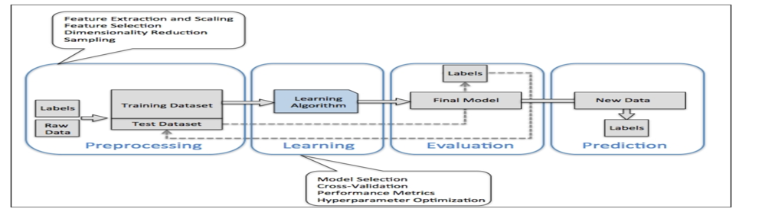

*Figure 6*

*Sebastian Raschka proposed a 4 steps procedure for supervised learning. From left to right Preprocessing, Learning, evaluation and prediction. In our procedure we sequentially preprocess our data, select, evaluate and scale our features, reduce dimensionality and classify with the best model. Adopted from Sebastian Raschka,, Python Machine learning, (2015)*

*Algorithms and methods*

The goal of Classification and Regression Trees (CART) is to partition data into disjoints sets (Breiman, 2001). Decision trees learn by inducing rules from observations in order to achieve this (Quinlan, 1985). In the classification setting, each observation has features that takes on a set of discrete or continues values (Quinlan, 1985). A decision tree splits the data based on question with regards to these features in order to partition the data into classes. Table 1 illustrates an example dataset. The features and their values propose an inference rule to classify observations. Essentially these rules can be expressed as a decision tree as in figure 3 or as If-then statements (Kuhn & Johnson, 2016)

Table 4.

*Example dataset with observation, features and classes. If it rains outside and the temperature is hot and it is Windy and it rains outside. We can see that observation plays outside. Adopted from Induction of Decision Trees, by R. Quinlan, 1986, Machine Learning. 1. P. 87.*

|  |  |  |  |  |  |
| --- | --- | --- | --- | --- | --- |
| **Observation** | **Features** | | | | **Class** |
|  | Windy | Temperature | Humidity | Rain |  |
| **1** | Yes | Hot | High | Yes | Play outside |
| **2** | No | Cold | Normal | No | Don’t play |
| **3** | Yes | Mild | Low | yes | Play outside |

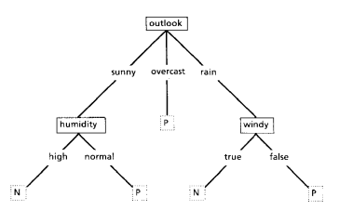

*Figure 3.*The N and P are called leafs and the nodes represent a feature and a “test” too which an answer decides which edge should be followed. Following from the top of the tree, the root, to a leaf. Each node represents a question through which an observation flows through downwards until it comes to a halt in an end leaf which represents the class of the observation. Adapted from Induction of Decision Trees, by R. Quinlan, 1986, Machine Learning. 1. P. 87.

Decision trees predict by capturing relevant relations (rules) between the attributes of features and a class in order to generalize to unseen observations (Breiman, 2001). Unseen observations follows the nodes up from the root of the tree (i.e. outlook) to the leafs of the tree (i.e. N or P). The label of a new observation is based on the most occurring class in the leaf (James, Witten, Hastie & Tibshirani, 2014).

*Gini Coefficients and feature importance*

Decision Trees are built to maximize the homogeneity at each node split (James et al., 2014). Homogeneity in the context of decision trees is called purity (Louppe, 2014). Purity of leafs is important because the classification of a new observation is based on the most occurring class in a leaf. The pureness of leafs increases the certainty and the quality of the classification (James et al., 2014). The Gini coefficient is a metric that assess how pure the classes are after a split with respects to the feature (James et al., 2014).

Suppose we have a dataset with classes *K*1, *K*2 … *K*n and the fraction of a class *K*. Then the Gini coefficient given by the sum of all classes *K1* (1 - *K1* ) +  *K2* (1 - *K2* )…. +  *Kn* (1 - *Kn* ) (James et al., 2014). The index is a number between 0 and 1. A small value for the Gini coefficient points at that the observations in the dataset are predominantly homogeneous and a high index relates to mixed classes (James et al., 2014). Formally we can define the Gini coefficient as:



Decision Trees have to consider which feature to split by first, by calculating how much the impurity decreases after a split (Breiman, 2001). The relative ranking that is formed is used as a measure of feature importance (Breiman, 2001; Louppe, 2014). The concept of Information gain is related to decrease in impurity in the sense that features that decrease impurity as measured by the Gini-index are informative (Breiman, 2001). This means that a feature with high impurity decrease, partitions the data better (separates the classes better) so we say that features that decrease impurity have high information gain, thus are more informative and have priority when constructing a decision tree (James et al., 2014). The scikit-learn implementation computes feature importance as the normalized reduction in Impurity as measured by the Gini-coefficients (sklearn, decisiontreeclf documentation).

*Ensemble methods: Exta trees and Random forests*

Random Forest is an ensemble method that combines multiple Decision Tree classifiers trained on random samples from the training data and averages the output (Breiman, 2001; James et al., 2014). Figure 4 shows the structure of the Random Forest method. A favorable property of the Random Forest is that it decorrelates features by considering only a subset of the predictors in each tee that is part of the ensemble (Breiman, 2001). A common threshold is to use the square root of the total predictors in the predictor space (James et al., 2014). Given predictors *P* the amount of predictors used in the random forest is given by .

By constantly considering a random sample of predictors and not the full available predictor space the random forest ensures that predictors with high information gain are not consistently used as the root for every tree (James et al., 2014). The use of the same tree would lead to highly correlated trees and a smaller reduction in variance across the individual classifiers (James et al., 2014). In terms of feature importance, the Random Forest averages the calculated Gini Index over all trees in the ensemble (James et al., 2014).

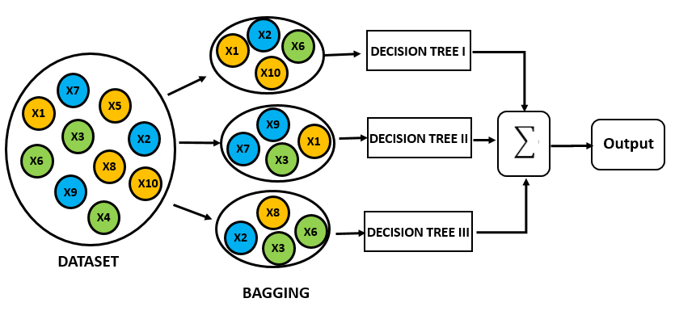

*Figure 4*

*The Random Forest method reduces variance, by bootstrapping subsets of the training data and building a model with varying predictors and then aggregating the results. Building the exactly the same model is a known statistical method called bagging (James et al., 2014).*

The Extra Trees classifier is another ensemble method that is very similar to the Random Forest (Geurts, Ernst & Wehenkel, 2005). It differs in the way it considers its splits. The Extra Trees classifier chooses the predictors completely at random.

*K Nearest Neighbors*

The K nearest neighbors classifier is a non-parametric model that does not rely on assumptions about the data (James et al., 2014). This makes the algorithm suitable for learning without prior knowledge about underlying distributions (Kuhn & Johnson, 2016). The KNN algorithm classifies by storing all the data and assigning an unseen observation based on the nearest *K* data points in the feature space (James et al., 2014; Kuhn & Johnson, 2016). The measure of approximation between points is defined by the *Minkowski* distance measure and classification happens by estimating the probability of the new observation based on the classes of the neighboring data points (Kuhn & Johnson., 2016; James et al., 2014). Given two points Minkowski distance function is given by:

Other measures such as the Euclidean distance @@ and Manhattan distance @@ tend to suffer from higher dimensional data and noise (above 3) (Zimek, Schubert & Kriegel, 2012).

The KNN can overfit when the K is set too low (e.g. K=1) (Kuhn & Johnson, 2016). A too low *K* parameter is too localized whereas a too high K (depends on the data) might lead to boundaries that do not capture any underlying structure in the data (Kuhn & Johnson, 2016). Hence, *K* is a parameter that needs to be tuned by trying out several values of K. In addition, KNN is a distance based algorithm and relies on scaling of predictors in the case of different scales (Kuhn & Johnson, 2016, James et al., 2014). Unscaled predictors leads to predictors with larger scales (Kuhn & Johnson, 2016).

***On using PCA before KNN***

*Shaw, Blake, and Tony Jebara. 'Structure preserving embedding. Proceedings of the 26th Annual International Conference on Machine Learning. ACM,2009*

***On KNN and distance features.***

[*https://www.ncbi.nlm.nih.gov/pmc/articles/PMC4978658/*](https://www.ncbi.nlm.nih.gov/pmc/articles/PMC4978658/)

*Principal component analysis*

Principal component analysis is a dimensionality reduction technique that can serve as a tool to summarize high dimensional data into principal components that explain most of the variability in the data (James et al., 2014). In addition, principal components are useful as visualization method.

Principal components are calculated by optimizing variance. If data contains measures on different scales. For an example: fixation duration in time and number of fixations in numbers. In order to not bias Principal components towards measurements that have high variance data should be standardized or scaled (Kuhn & Johnson, 2016). Given a vector denoted by . Standardizing is done by subtracting the mean and dividing by the standard deviation. Formally we can write this as:



A well-known alternative to standardizing is normalizing. With Min-Max scaling the data is scaled to a bounded range (i.e. between 0 -1). Given a vector denoted by we can normalize our vector of data points by subtracting the lowest value ) from every data point in and divide by the difference between the highest value ) and the lowest value ). The resulting scaled vector is bounded by the new range. Formally we can write this as:



**Scoring and classification**

The most common measures for evaluation of classification models rely on measures of information retrieval systems such as precision, recall, accuracy and specificity (James et al., 2014). This values can be computed from a confusion matrix as shown in table 5. Confusion matrices are used to obtain different classification metrics that enables to assess the validity of a classification model in the context of their goals (Kuhn & Johnson, 2016). A metric of a classification model should adhere to the notion of relevancy of the use case@@.

|  |  |  |  |
| --- | --- | --- | --- |
|  | | | |
| **Predicted values** | **Actual values** | | |
|  | Positive | Negative |
| Positive | True Positives | False Positives |
| Negative | False negatives | True Negative |

*Table 5.Confusion matrix*

The matrix offsets a predicted value against the actual value in terms of errors. For an example if an observation is classified as belonging to a class and the actual class is the same as predicted the confusion matrix tells us that it is a true positive.

In the case of a clear goal a choice for a metric would be more straightforward. For an example, a classification model that is built to find terrorists on an airport should have high recall. Since it is probably better to find each possible observation of danger in comparison to assessing how well your model pinpoints the different classes (i.e. terrorist versus non terrorist).

## Experimental procedure

Two methods are followed. A Principal component analysis was performed in order to find not straightforward components that can be used to classify and inspect the data. The PCAs where used to train the K Nearest Neighbors algorithm and to evaluate whether eye gaze information contain information. And feature importance was evaluated on the basis of Tree bases ensemble methods. Both the KNN algorithm and Tree ensemble classifiers were used to predict skill level.

**Dataset processing and feature selection**

*Features*

The variables used in this study were selected in accordance with the premises of the information reduction theory and adopted from Gegenfurtner et al. (2011) with a few augmentations. Global percentage looked at exit and entry points, moveable objects and evidence were computed for both datasets by dividing the amount of time fixated on one of these regions of interest and dividing it by the total fixation duration and multiplying it with 100. The measures for the global features were aggregated per participant over all images for both datasets. The fixation coordinates (pixel values) were computed by summing the difference between the X- and Y-coordinates and the consecutive X- and Y-coordinates for every fixation. This was squared and then the square root was taken. Formally we can write this down as:



We hypothesized that experts have more fixations on relevant objects and fewer fixation on redundant objects. Relevant fixations (duration and number of fixations) are computed by amounting the numbers or the time spent looking at evidence. Redundant fixations (duration and number) are computed by amounting the number and time spent at not looking at evidence.The features differed between the local and global analysis because the global analysis was aggregated per participant. In addition, mean values were computed since participants viewed multiple images. Table 5 shows an overview of the features and a division per level.

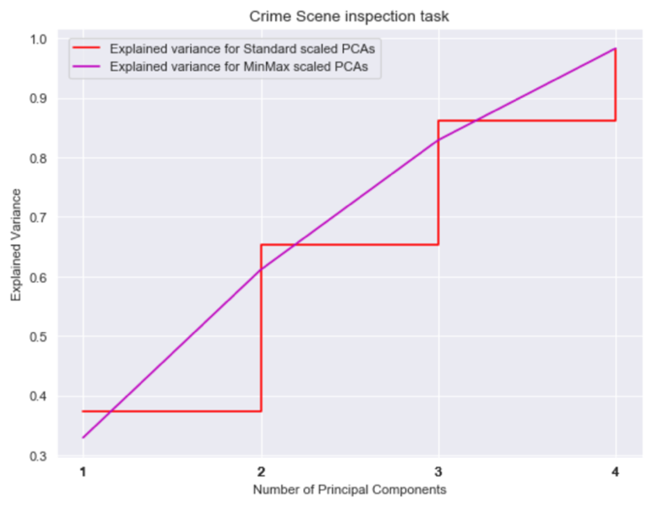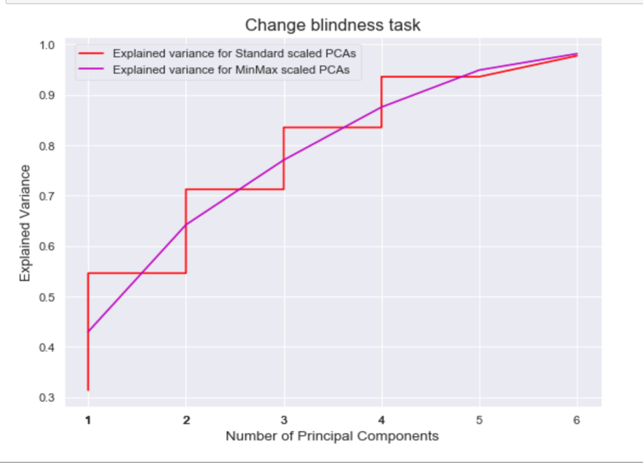

Figure 7. Scree-plots show that for the crime scene inspection task 98% of the variance in skill can be accounted to 4 components. Similarly 98% of the variance in skill can be attributed to 6 components in the change blindness dataset. Computations were done by conducting a Grid search on values ranging from 1% to 100% in steps of 5%.

|  |  |  |
| --- | --- | --- |
|  | Crime scene exploration task | Change blindness task |
| Global  *Aggregated per participant* | % looked at exit and entry points  % looked at moveable objects  % looked at evidence  Mean fixation duration  Mean relevant and irrelevant number of fixation  Mean fixation coordinates (Pixels)  4 principal components | % looked at exit and entry points  % looked at moveable objects  % looked at evidence  Mean fixation duration  Mean relevant and irrelevant number of fixation  Mean fixation coordinates (Pixels)  6 principal components |
| Local  *Aggregated per photo* | Relevant/irrelevant number of fixations  Relevant/irrelevant Fixation duration | Relevant/irrelevant number of fixations  Relevant/irrelevant fixation duration |

*Table 5. Operationalization of theories to eye movement measures. The features are divided into a Global level and a Local level. Adopted from Gegenfurtner et al. (2011)*

Feature correlations are computed for both datasets and inspected. Figure 7 shows the pairwise correlations between features. Most features do not correlate with each other. Strong correlations are found between relevant fixation duration and fixation duration *r* = .99 but this was expected to correlate since relevant fixations are computed from the total fixation duration. Similarly irrelevant number of fixations and relevant fixations correlated. These feature were not excluded from analysis since Random Forests decorrelates features by only considering a subset of features while building randomized decision trees. Furthermore, the correlations between features were masked as a result of using Principal Components.

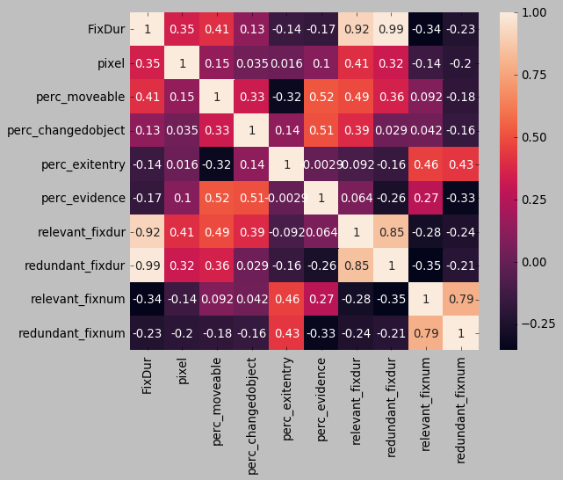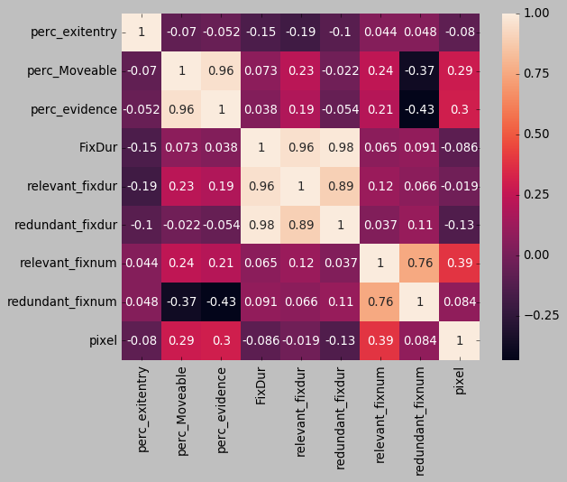

Change blindness task dataset feature correlation Crime scene inspection task dataset feature correlations

*F*igure 7. Correlations between features. Pearson’s R was used to compute pairwise correlations between all the features in both datasets.

*Resulting datasets*

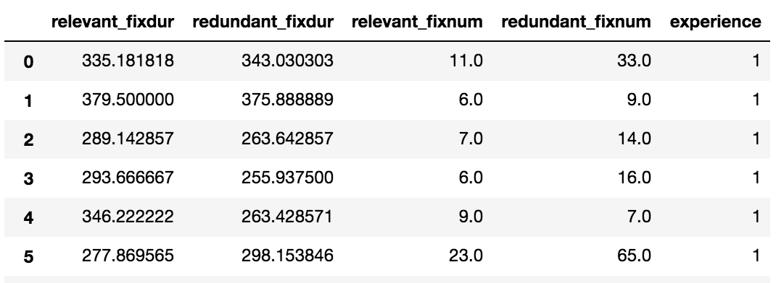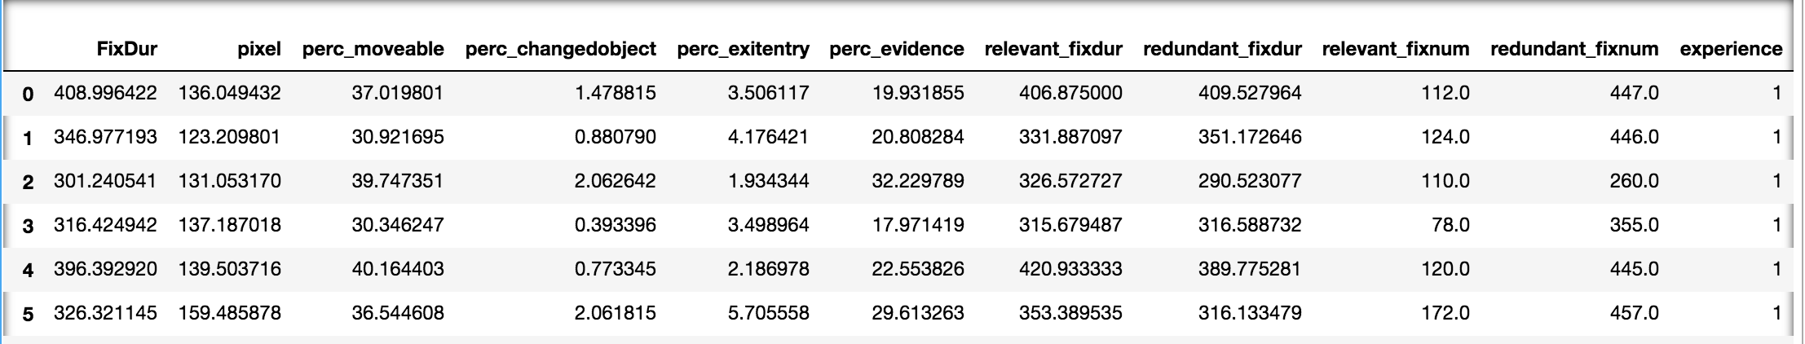

*Table 3. Overview of resulting datasets used for analysis*

|  |  |  |  |
| --- | --- | --- | --- |
|  | Change blindness task | Crime inspection task |  |
|  |  |  |  |
|  |  |  |  |
|  |  |  |  |

Train & test split

The dataset was split into a train and test set. The data was divided into a train/validation set 67% (22 instances) and a test set 33% (11 instances) for the Crime scene inspection dataset. The data for the Change blindness dataset was similarly divided into 67% train/validation set (13 instances) and a test set 33% (7 instances)

***Learning and feature importance***

5-fold cross validation has shown that K=3 for the CB task and K= 7 for both standard and MinMax scaled for the visual search task. The best K was used for predictions. Figure 8 illustrates the

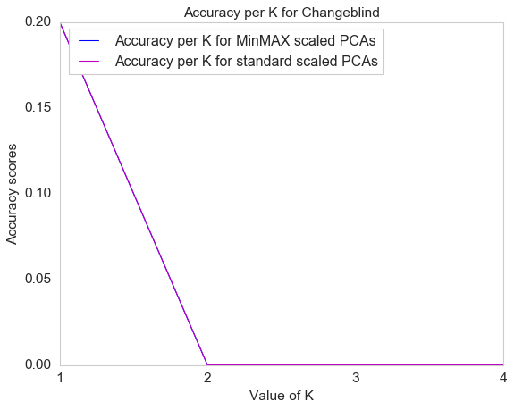

*Figure 8.* shows the hyperparameter tuning for the best value of K.

Left shows the accuracy per K on the train set for the Change blind dataset and right shows the accuracy per K for the crime scene inspection dataset.

Feature importance based on Gini coefficients were performed in order to determine which features contain the most information on skill. Information gain was computed for each of the features.

Figure 5

This research makes use of the F1-measure. This measure considers both precision and recall and finds a balance between both.

The local analysis will be evaluated with ROC curves in order to evaluate the area under the curve for the classification models. While ROC Curves are the standard in evaluating model performance. This study will make use of the F1 measure that combines precision and recall. This facilitates comparison between models. With no clear objective in mind (i.e. terrorist detection) other than finding a

***Hyperparameters and Algorithm training***

Following the aforementioned similarity between both classifiers and the possibility to run the treebased models in parallel. Crossvalidation was performed using a gridsearchCV functionality in sklearn. Table 3 shows the parameter tuning for both the Tree Classifiers and the KNN- score.

The Random Forest and Extra Trees classifier were trained using Grid search cross validation. The parameters that were observed can be found in table 3.

|  |  |  |
| --- | --- | --- |
|  |  |  |
| **Parameters** | **Definition** | **Grids for both classifiers** |
| Max_depth | Represents the Depth of each tree. | [2,3,4,5] |
| Min_samples_split | The minimum amount of samples needed before a node can make a split. | [2,3,4,5] |
| Min_samples_leaf | The required minimum of samples at a leaf. | [2,3,4,5] |
| Max_features | The number of predictors considered at each split. | [2,3,4,5] |

*Table 3*

*Parameter tuning in tree-based methods*

Why to not OVERTUNEEEE

<http://www.jmlr.org/papers/v3/reunanen03a.html>

*Change blindness and visual search parameter tuning for KNN*

The most important parameter in the K nearest neighbor’s algorithm is obviously the K. Parameter tuning for K showed that in the Change Blindness task the MinMax scaler seem to classify the objects with maximum accuracy.

Table 4:

Parameter tuning for KNN. For both datasets the data was standard scaled to mean and standard deviation and MinMax scaled between 0 and 1.

The f1-measure can be seen as a measure of preciseness but also robustness @@ data-skeptic

[**http://www.dcs.gla.ac.uk/Keith/Chapter.7/Ch.7.html**](http://www.dcs.gla.ac.uk/Keith/Chapter.7/Ch.7.html)

[**https://www.bioinfopublication.org/files/articles/2_1_1_JMLT.pdf on f1**](https://www.bioinfopublication.org/files/articles/2_1_1_JMLT.pdf%20on%20f1) **scores**

**On F1 measures:**

[**https://stats.stackexchange.com/questions/49226/how-to-interpret-f-measure-values**](https://stats.stackexchange.com/questions/49226/how-to-interpret-f-measure-values)

**Results**

**1 Feature analysis and prediction across tasks**

**RQ2) *Do eye movement measures within the CSI domain contain enough information in order to predict Skill (Expert or novice) on the basis of eye movement parameters ?***

* In terms of Feature importance relevant fixation number doesn’t do very well globally. Both with 4 groups as with 2 groups. Fixation duration actually contains more information looking at Eyelink.

***Principal component analysis***

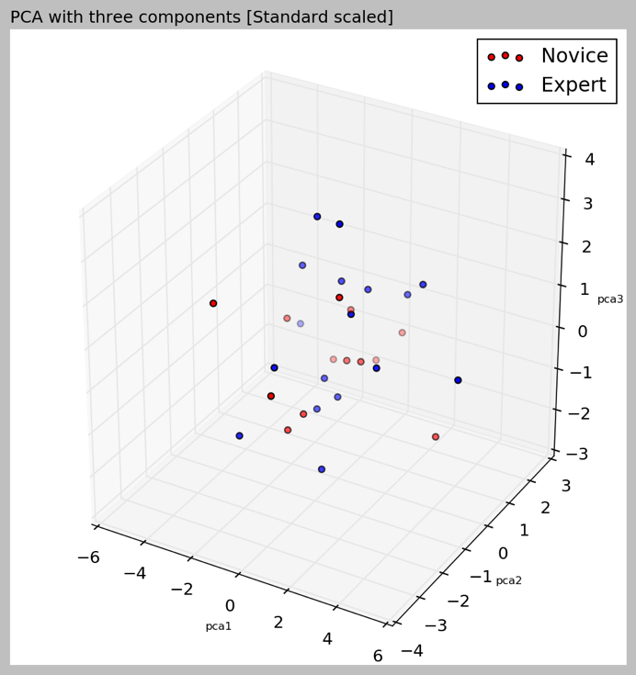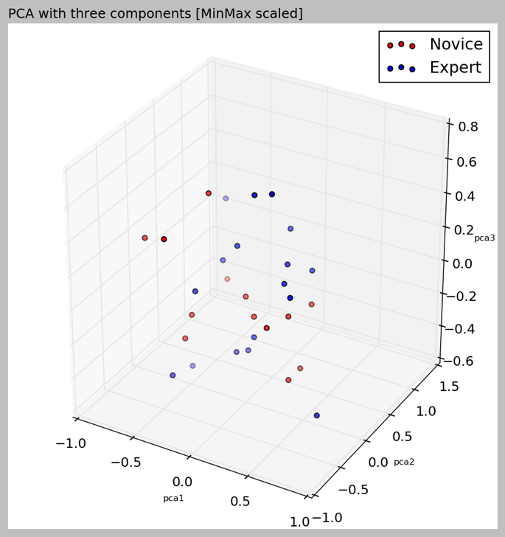

Principal components were used to explore the data and as a preprocessing method for the K- Nearest Neighbors algorithm.

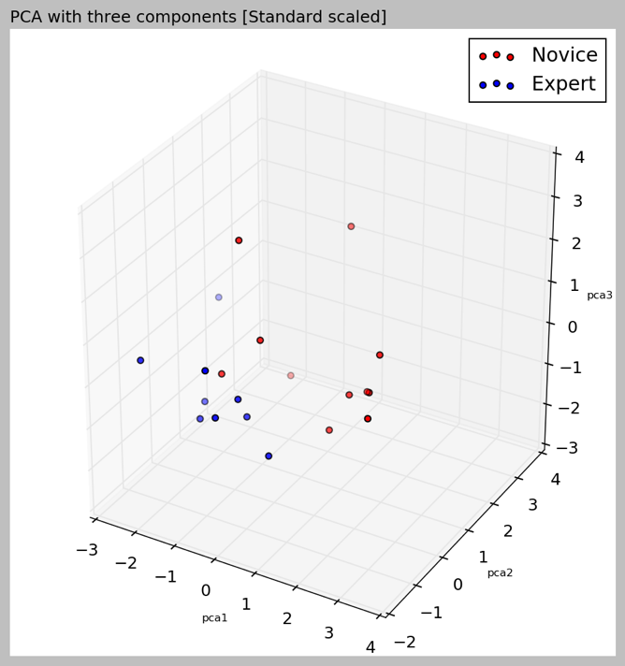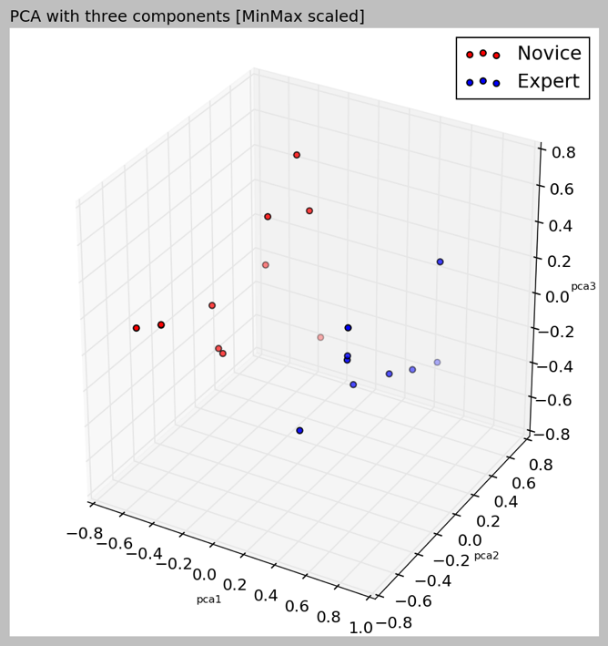

**Feature analysis**

*Results Extratreesclassifier*

**On change blindness task**

**Figure 7**

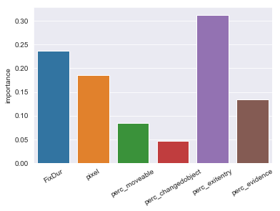

**On visual search task**

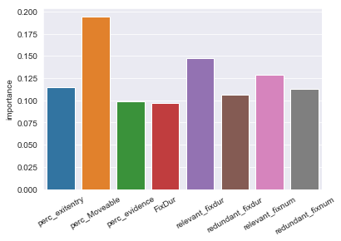

**Feature importance per image/ locally**

On change blindness task per image

Change_blind average performance of ensemble classifiers.

|  |  |  |  |
| --- | --- | --- | --- |
|  | performance | mean | std |
| 0 | extratrees_model_best | 0.607514 | 0.164567 |
| 1 | f1_score_extra | 0.225191 | 0.327472 |
| 2 | forest_model_best | 0.607021 | 0.168777 |
| 3 | f1_score_fost | 0.404035 | 0.475403 |

Local Prediction

|  |  |  |  |  |
| --- | --- | --- | --- | --- |
|  | Extra Trees Classifier | | Random Forest Classifier | |
| Image | E**xtra** trees | **f1** **score** | **f1_score_forest** | **forest_model_best** |
| 1 | 0.615385 | 0.476190 | 0.874459 | 0.692308 |
| 2 | 0.600000 | 0.066667 | 0.400000 | 0.600000 |
| 3 | 0.615385 | 0.035714 | 0.285714 | 0.615385 |
| 5 | 0.454545 | 0.166667 | 0.166667 | 0.454545 |
| 6 | 0.428571 | 0.333333 | 0.733333 | 0.428571 |
| 7 | 0.583333 | 0.342857 | 0.415584 | 0.583333 |
| 8 | 0.666667 | 0.415584 | 0.415584 | 0.583333 |
| 9 | 0.615385 | 0.035714 | 0.628571 | 0.615385 |
| 10 | 0.615385 | 0.035714 | 0.035714 | 0.615385 |
| 11 | 0.700000 | 0.228571 | 0.228571 | 0.700000 |
| 12 | 0.700000 | 0.166667 | 0.166667 | 0.700000 |
| 13 | 0.666667 | 0.166667 | 0.444444 | 0.666667 |
| 14 | 0.636364 | 0.457143 | 0.457143 | 0.636364 |

Feature importance overall.

| **extratrees_model_best** | **f1_score_extra** | **f1_score_forest** | **forest_model_best** | **image** | **important_feature_value** |
| --- | --- | --- | --- | --- | --- |
| **important_feature** |  |  |  |  |  |  |
| **redundant_fixdur** | 0.624359 | 0.076190 | 0.291468 | 0.624359 | 7.000000 | 0.311981 |
| **redundant_fixnum** | 0.586747 | 0.310444 | 0.558658 | 0.565913 | 9.250000 | 0.343264 |
| **relevant_fixdur** | 0.641667 | 0.254762 | 0.291126 | 0.641667 | 9.500000 | 0.325474 |
| **relevant_fixnum** | 0.589977 | 0.290476 | 0.423232 | 0.615618 | 5.666667 | 0.383299 |

Best :

Image 1, 7,

.Test performance of everymodel.

* **Counts on relevant seeming features**

**2 Prediction and consistency across tasks**

Performance per K

|  |  |  |  |  |
| --- | --- | --- | --- | --- |
| Value of K | Task: Change Blindness | | Task: Crime scene inspection | |
|  | Standardized | MinMax | Standardized | MinMax |
| 3 | 0.6 | 1 | 0 | 0.0 |
| 5 | 0.2 | 1 | 0 | 0.0 |
| 7 | 0 | .6 | 0.1 | 0.1 |
| 9 | 0 | 0 | 0.1 | 0.1 |
| Performance |  |  |  |  |

***Performance per image***

***-Highlight important images***

***- Counts on important images***

RQ 1) *Are there differences in the number of fixations on task relevant and task redundant areas between CSI experts and novices as a consequence of the information reduction hypothesis?*

* ***Kick out other groups from eyelink-dataset.***

**3. Wat valt op/ welke patronen zien we?**

**Discussie: waar komt dat dan door? En linken aan theorie. B[;[**

1. **RQ1**

*Figure @@*

*Relevant fixations (on Evidence) between Control, First year Third Year and CSI*

*Left is relevant and right is redundant.*

Figure @@

Comparison of number of fixations between both experts and novices.

Left is relevant, right is redundant

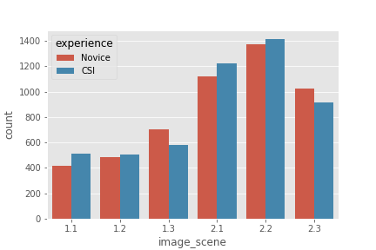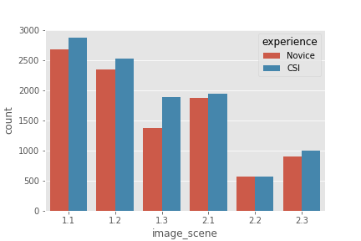

Here we saw that fixation duration and, percentage of time looked at exitentry points, percentage of time looked at moveables and pixel coordinates where the best predictors for a certain class.

**Discussion**

*KNN and PCA are distance based methods and therefore perform better if everything is scaled. Two methods were performed. MM versus STD and while the trajectory looks different. They arrive at the same amount of PCAs.*

* It is unclear whether the eye measurement differences are really symptoms of a better csi. While the methods used in this research point out which eye movement patterns are important and which eye movement pattern measures are consistently different between experts and novice csi. It remains unclear to which extent these measurements reflect upon certain acquired skill.
* The premises of these theories resonates by moderating the expertise effect. When visual stimuli contain an abundance of information. In contrast to novices, experts can rely on mental cues encapsulated in the long term working memory while processing information (Gegenfurtner, Lehtinen & Saljo, 2011). Hence redundant information and in visual stimuli is disadvantageous to novices.
* A second aspect that can modify the gap between experts and novice eye movement patterns is the nature of the task. In eyetracking research a variety of different tasks have been used without keeping account for the influence of task complexity on detected difference sizes ( Gegenfurther et al., 2011).
* Why is such an approach to skill assessment important? It is critical to assess surgeon skill for a number of reasons. Objective measurement of skill is necessary to monitor the progression throughout surgical training programs and a prerequisite for meaningful credentialing. Ensuring surgical skill and competency is critical to limit the incidence of iatrogenic injury and medical errors, which are alarmingly common.1 Unfortunately, however, the assessment of surgical skill remains a rudimentary science. Currently, the best available method appears to be direct observation of operative performance with a global rating scale.32 While this method has validity, direct observation is subject to biases, requires expert “judges” to be present, and is associated with significant time demand. Richstone et al (2010)

**Possible implications**

* : information reduction theory (might extend to csi since dynamics are similar). Lessons can be drawn from studies in which scanning behaviors can be used for novices to adopt. Mostly oculomotor eye movement parameters can be used in teaching.

**Further research**

* Evaluate the measures on a bigger dataset with more participants and see if they are also consistent there.
* include event-driven approach in your research.

**Limitations**

* First, **participants in this study were sampled from a fixed geographical** location, which confines the above conclusions to a single cohort, and therefore not necessarily representative of the entire population of crime scene examiners.
* One of the main problems with research in the expert novice paradigm is the scarcity of experts.

Mills et al., (good example paper to describe methods section)

<http://www.educationaldatamining.org/EDM2016/proceedings/paper_143.pdf>

* Feature selection was used on the training set of each crossvalidation fold (see below). Features were ranked using correlation-based feature selection (CFS) [15] from Weka and the top 30%, 50%, or 80% of features ranked were retained.

Other methods for feature_selection could have been tried.

Future research

* Future research can extend the followed methodology by aggregating per participant per image. The models that were trained locally evaluated class based on **losse** fixations.
* **variability of real crime scenes** Third, a homicide/shooting reconstruction scene was evaluated, and as such, the results found here may not be transferable to all types of crimes (note that 22 of the 32 participants in this study (69%) reported experience with shooting scenes).
* Only focus on subset of eye gaze information the direct parameters. while there are others such as spatial distribution, string-based and geometric and probabilistic approaches.
* this was data driven maybe because (pro’s of event driven as opposed to data driven [find out what they are]) were prevalent in this study.
* [why the mobile eyetracking might not show good results.] such as the spatial bias to the center region [[7]](https://journals.plos.org/ploscompbiol/article?id=10.1371/journal.pcbi.1000791#pcbi.1000791-Tatler1) and geometric properties of saccades [[8]](https://journals.plos.org/ploscompbiol/article?id=10.1371/journal.pcbi.1000791#pcbi.1000791-Brockmann1)

# 

*Implications:*

* *Standardized surgical skills test in a trainer or simulator or alternatively submit eye metric performances for certification or review Richstone et al 201*

*[Extra]*

In accordance with the long-term working memory theory we hypothesize that experts in the CSI domain display overall shorter fixation duration **h1**.

In accordance with the holistic approach to perception we estimate that expert CSIs will have shorter saccade amplitudes and need shorter time to fixate their first.

# References

Ahmidi, N., Hager, G. D., Ishii, L., Fichtinger, G., Gallia, G. L., & Ishii, M. (2010). Surgical task and

skill classification from eye tracking and tool motion in minimally invasive surgery. *In Medical image computing and computer-assisted intervention*. Vol 13, 295–302 Retrieved from

Ahmidi N, Ishii M, Fichtinger G, Gallia GL, Hager D. (2012). An objective and automated

method for assessing surgical skill in endoscopic sinus surgery using eye‐tracking and tool‐motion data *Int Forum Allergy Rhinol*. 2012;2:507–515 Retrieved from <https://doi.org/10.1002/alr.21053>

Baber, C., Butler, M., (2012) Expertise in crime scene examination: comparing search strategies

of expert and novice crime scene examiners in simulated crime scenes. *Human Factors: The Journal of the Human Factors and Ergonomics Society.* 54(3), 413–24. Retrieved from <http://journals.sagepub.com/doi/10.1177/0018720812440577>

[Breiman L](https://en.wikipedia.org/wiki/Leo_Breiman) (2001). "Random Forests". [*Machine Learning*](https://en.wikipedia.org/wiki/Machine_Learning_(journal)). **45** (1): 5–32. [doi](https://en.wikipedia.org/wiki/Digital_object_identifier):[10.1023/A:1010933404324](https://doi.org/10.1023%2FA%3A1010933404324).

Turvey, B.E. Freeman, J. (2017). Chapter 5 - Crime Scene Investigation and Analysis. *Forensic.*

*Investigations.* 91-123. Retrieved from <https://doi.org/10.1016/B978-0-12-800680-1.00005-5>.

Coutrot, A., Hsiao, J.H. & Chan, A.B. (2018). Scanpath modeling and classification with hidden

Markov models. *Behavior Research Methods* 50: 362. Retrieved from <https://doi.org/10.3758/s13428-017-0876-8>

Busey, T.A. & Parada, F.J. (2010). The nature of expertise in fingerprint examiners. *Psychonomic*

*Bulletin & Review* 17: 155. https://doi.org/10.3758/PBR.17.2.155

Decroix, M., Norjali Wazir, M.R.W., Zeuwts, L., Deconinck, F. F.J.A., Lenoir, M.,

Vansteenkiste, P. (2017). Expert – Non-expert differences in visual behaviour during alpine slalom skiing, *Human Movement Science*. 55, 229-239. Retrieved from <https://doi.org/10.1016/j.humov.2017.08.012>

Dyer, A. G., Found, B., & Rogers, D. (2006). Visual Attention and Expertise for Forensic

Signature Analysis. Journal of Forensic Sciences, 51(6), 1397-1404. Retrieved from doi:10.1111/j.1556-4029.2006.00269.x

Campbell, D. J. (1986). Task complexity: A review and analysis. Academy of Management Review, 13,

40– 52. Retrieved from <https://doi.org/10.5465/amr.1988.4306775>

Gegenfurtner, A., Lehtinen, E., & Säljö, R. (2011). Expertise differences in the comprehension of

visualizations: A meta-analysis of eye-tracking research in professional domains. Educational Psychology Review, 23(4), 523-552.

<http://dx.doi.org/10.1007/s10648-011-9174-7>

Hermens, F., Flin, R., & Ahmed, I. (2013). Eye movements in surgery: A literature

review. Journal of eye movement research, 6(4), [4]. Retrieved from <http://dx.doi.org/10.16910/jemr.6.4.4>

Hunt, A. R.; Kingstone, A. (2003). "Covert and overt voluntary attention: Linked or

independent?". Cognitive Brain Research. **18** (1): 102–105.Retrieved from <https://doi.org/10.1016/j.cogbrainres.2003.08.006>

Jarodzka, H. Scheiter, K. Gerjets, P., Gog., T. (2010) In the eyes of the beholder: How experts and

novices interpret dynamic stimuli. *Learning and Instruction*. Volume 20, Issue 2, Pages 146-154.

Retrieved from https://doi.org/10.1016/j.learninstruc.2009.02.019

Rayner, K. 1998. Eye Movements in Reading and Information Processing: 20 Years of Research.

Psychological Bulletin. 124, 3 (Nov. 1998), 372. Retrieved from <http://dx.doi.org/10.1037/0033-2909.124.3.372>

Richstone L, Schwartz MJ, Seideman C et al: Eye metrics as an objective assessment of surgical

skill. Ann Surg, 2010; 252(1): 177–82. Retrieved from [http://dx.doi.org/**10.1097**/**SLA**.**0b013e3181e464fb**](http://dx.doi.org/10.1097/SLA.0b013e3181e464fb)

Rizzolatti G, Riggio L, Dascola I, Umilta C (1987) Reorienting attention across the horizontal and vertical

meridians: evidence in favor of a premotor theory of attention. Neuropsychologia 25: 31–40.

Ozger, M. (2016 ) Paying attention to the evidence: a comparison of perception and decision

making processes in novice and experienced scene of crime officers using eye tracking in simulated crime scene scenarios. PhD thesis, University of Lincoln. Retrieved from <http://eprints.lincoln.ac.uk/26649/>

Prytz., E.G., Norén, C., Johnson., C. (2018). Fixation Differences in Visual Search of Accident Scenes by

Novices and Expert Emergency Responders. *Human Factors: The Journal of the Human Factors and Ergonomics Society* Retrieved from [https://doi.org/10.1177/0018720818788142](https://doi.org/10.1177%2F0018720818788142)

Vickers, J.N. (1992). Gaze control in putting. *Perception 21, 117-132.* Retrieved from

<https://doi.org/10.1068/p210117>

Vine, S. J., Chaytor, R. J., McGrath, J. S., Masters, R. S., and Wilson, M. R. (2013). Gaze

training improves the retention and transfer of laparoscopic technical skills in novices. *Surgical Endoscopy*. 27(9), 3205–3213. Retrieved from <https://doi.org/10.1007/s00464-013-2893-8>

Watalingam, R.D, Richetelli, N., Pelz, J.B., Speir, J.A. (2017).

Eye tracking to evaluate evidence recognition in crime scene investigations,

*Forensic Science International*. 280, 64-80. Retrieved from <https://doi.org/10.1016/j.forsciint.2017.08.012>

Wood, R. E. (1986). Task complexity: Definition of the construct. Organizational Behavior and

Human Decision Processes, 37, 60–82. Retrieved from <https://doi.org/10.1016/0749-5978(86)90044-0>

Bruce and tsosos

chrome-extension://laookkfknpbbblfpciffpaejjkokdgca/dashboard.html

CLF and gini impurity

<https://scikit-learn.org/stable/modules/generated/sklearn.tree.DecisionTreeClassifier.html#sklearn.tree.DecisionTreeClassifier.feature_importances_>

Jocelyn D’souza picture of randomforrests

<https://medium.com/greyatom/a-trip-to-random-forest-5c30d8250d6a>

Quinlan, Ross. (1986). Induction of Decision Trees. Machine Learning. 1. 81-106. Retrieved from <https://doi.org/10.1023/A:1022643204877>

Gareth James, Daniela Witten, Trevor Hastie, and Robert Tibshirani. 2014. An Introduction to Statistical Learning: With Applications in R. Springer Publishing Company, Incorporated.

P. Geurts, D. Ernst., and L. Wehenkel, “Extremely randomized trees”, Machine Learning, 63(1), 3-42, 2006.

<https://scikit-learn.org/stable/modules/generated/sklearn.preprocessing.StandardScaler.html>

<https://scikit-learn.org/stable/modules/generated/sklearn.preprocessing.MinMaxScaler.html>

Raschka S (2015) Python machine learning. Packt Publishing Ltd, Birmingham

A. Zimek, E. Schubert, H.P. Kriegel, A survey on unsupervised outlier detection in high-dimensional numerical data. Stat. Anal. Data Min. ASA Data Sci. J. **5**(5), 363–387 (2012).  <https://doi.org/10.1002/sam.11161>

C.D. Manning, P. Raghavan, H. Schütze, [Introduction to Information Retrieval](http://nlp.stanford.edu/IR-book/html/htmledition/evaluation-of-ranked-retrieval-results-1.html), 2008.